Configuration Guide for Android File Applications:
Applications on your phone/tablet are a personal decision. With that in mind we have provided instructions for 2 common clients that you can use to access your Novell drives from your Android Phone or Tablet. This is not an endorsement of any particular app. Search the Google Play Store or other App Store for ‘WebDAV’ capable clients. The settings refered to below can be used for any WebDAV client. Should you have any issues configuring the client, please contact IT Support Centre @ 306-585-4685 or visit an IT Support Centre for assistance.
WebDAV File Manager:
Once you have installed WebDAV File Manager from the play store (Free), here are the steps to configure it to access your Novell drives:
- Start WebDAV File Manager:
- Tap the Menu Button (It has 3 lines on it, button usually found on the bottom right corner of the screen on your device). A menu will appear that contains an Item Called ‘Server Add’. Tap that item:
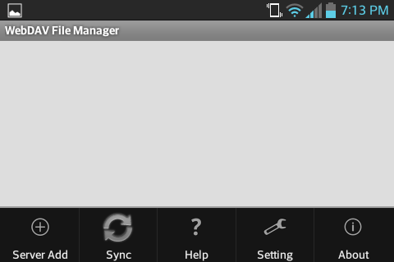
- As screen like this should appear. Type in a name for this Server Name (This can be anything that would make sense to you):
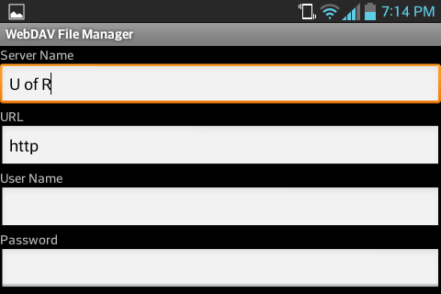
- Type in the server URL: https://netstorage.cc.uregina.ca/oneNet/NetStorage
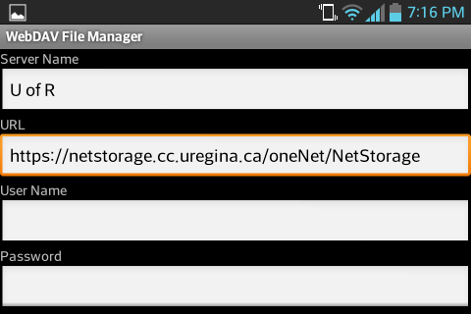
- Enter your Novell/Campus Wireless User Name
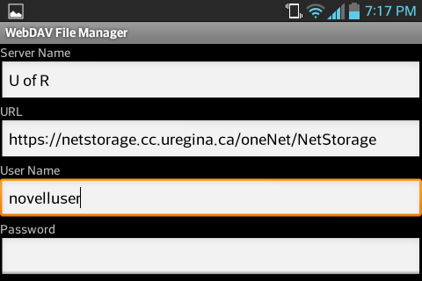
- Enter Your Novell/Campus Wireless Password
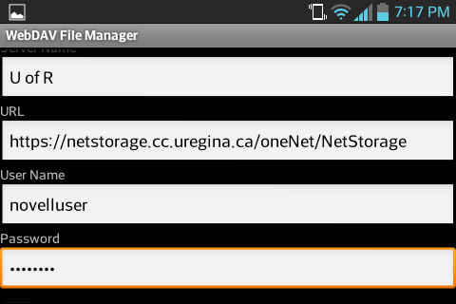
- Enter a Download Path – This is the directory on your device where any files downloaded from the server will be placed. You can leave this field as is unless you have a reason to change it:
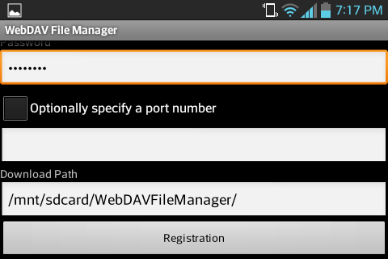
- Tap Registration. The End Result Will Look Like This:
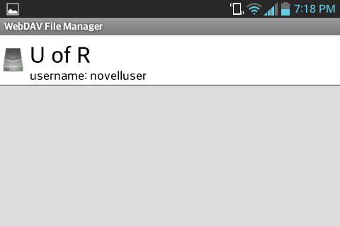
- Tap the name (in this case U of R). All of the drives you have access to will appear in the list on the resulting screen:
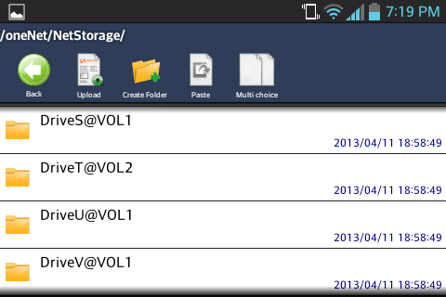

X-plore File Manager:
Once you have installed X-plore from the play store (Free), here are the steps to configure it to access your Novell drives:
- Start X-plore File Manager:
- You will see a screen that looks a little like this (this tutorial is in landscape orientation:
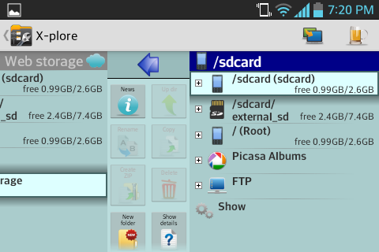
- Scroll to the left so that ‘Web storage’ is visible. Tap on ‘Add Server’ below ‘Web storage’:
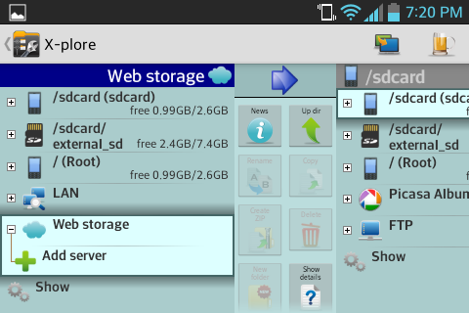
- Scroll the list of server types until you see ‘WebDav’. Tap ‘WebDav’:
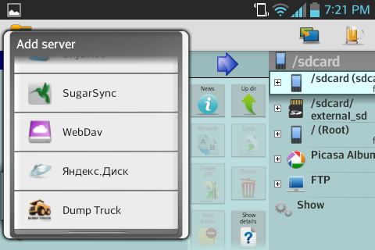
- When Edit Server Appears, Add a name to the Label Field. Type in a name for this server name (This can be anything that would make sense to you):
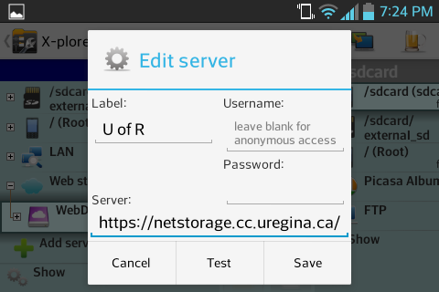
- Type in the server URL: https://netstorage.cc.uregina.ca/oneNet/NetStorage into the Server field:
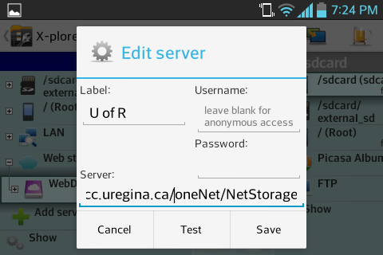
- Enter your Novell/Campus Wireless User Name:
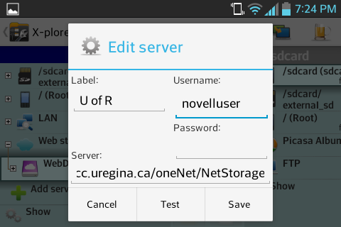
- Enter Your Novell/Campus Wireless Password:
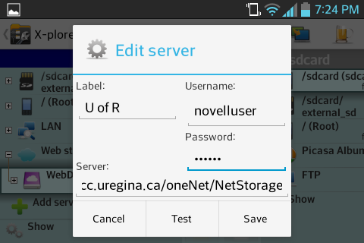
- Tap Test. If successful, Tap Save. The screen will look something like this:
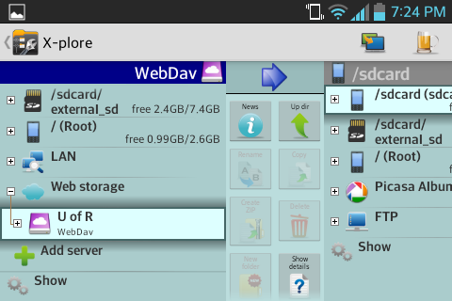
- To see the list of drives/folders, Tap the + sign beside the WebDav Name you created.
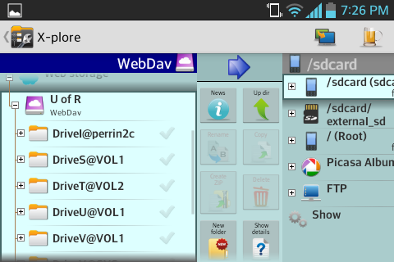
- The folders behave like they do on your computer

